# Geometrical optics

## Introduction

### Refraction

When light crosses the interface between two media having different refractive indices (e.g. between water and air) a light ray will appear to change its direction of travel. The direction of the incident and refracted rays are typically labelled by the “angle of incidence”, $θ_{1}$, and the “angle of refraction”, $θ_{2}$, as seen in Figure 1. The relation between this bending of the light and the relative refractive indices of two media is described by Snell’s Law:

|  |  |  |
| --- | --- | --- |
|  | $$n_{1}\sin{θ_{1}}=n_{2}\sin{θ_{2}} ,$$ |  |

where $n_{1}$ and $n_{2}$ are the indices of refraction of both media.

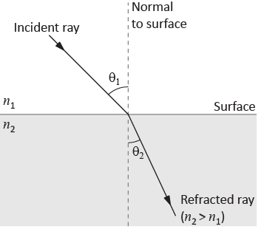

Figure - Refraction

### Light dispersion

The index of refraction for light varies with the wavelength (or colour) of the light. Consequently, white light that enters a material (at an angle other than 0°) will separate into its component colours as each wavelength is bent a different amount. In general, for visible light, index of refraction decreases with increasing wavelength. This means that the index of refraction for red (650 nm) is smaller than the one for blue (475 nm).

### Lenses

Lenses exploit the refraction of light by using continuously curving surfaces to either converge or diverge the incident light upon their surface. A thin lens is defined as one whose thickness is much smaller than the radii of curvature of its faces. The theory of thin lenses makes use of Snell’s law of refraction or of the more basic underlying fact that light waves travel more slowly in glass (or other refracting media) than they do in vacuum. The theory assumes that only thin lenses of small aperture will be used (the paraxial approximation). This is essentially equivalent to assuming that $\sin{x}=x$ and $\cos{x}=1$, where $x$ is a typical angle between light rays (in radians).

The results of this simple theory can be summarized in the so called “Thin lens equation”

|  |  |  |
| --- | --- | --- |
|  | $$\frac{1}{p}+\frac{1}{q}=\frac{1}{f} ,$$ |  |

where $p$ is the distance of a point object from a lens, $q$ is the distance of the corresponding image point, and $f$ is a constant of the lens known as its focal length.

### Construction rays

While the result of thin lens equation leads to a mathematical expression relating object and image distances (see eq. 2), you can also find image positions for particular cases by means of a quick sketch using the “construction ray” method. Any point of the object (not on the axis of the system) may be used.

1. A ray from the object parallel to the axis is refracted through $F_{2}$.
2. A ray directly through the centre of the lens is not deviated (since the lens at that point is a parallel sided piece of material).
3. A ray from $P$ through $F_{1}$ becomes parallel to the axis after refraction by the lens.

The image position will be the point where all refracted rays intersect (or appear to have come from in the case of a virtual image). This technique should be tried out for a variety of situations and the results compared with the predictions of eq. 2.

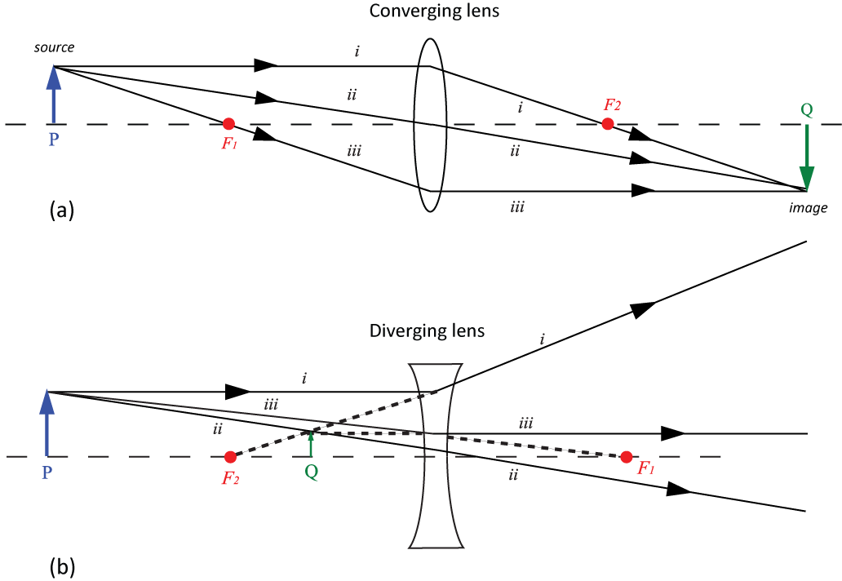

Figure – Construction rays for converging and diverging lenses.

### Types of lenses

A converging lens, as its name implies, tends to converge the rays of light. A diverging lens has the opposite effect (see Figure 2b). In each case the emerging rays from the point source $P$ pass through a point $Q$ which is called the image. In Figure 2a the image point is “real” in the sense that the rays actually converge at that point. In Figure 2b, the image point is said to be “virtual” because the rays only appear to have diverged from that point.

### Sign convention

In the derivation of the thin lens equation, a sign convention is used to make the equation applicable to every possible situation. In the simplest form the convention is as follows:

* $p$ is positive when the object is on the incoming side of the surface, negative otherwise.
* $q$ is positive when the image is on the outgoing side of the surface, negative otherwise.

### Focal length

The points on the diagram marked $F_{1}$ and $F_{2}$ are called focal points. They have the following significance:

* A ray of light parallel to the axis will pass through $F_{2}$ after being refracted by the lens. For the diverging lens the ray only appears to have passed through $F_{2}$.
* A ray of light passing through $F_{1}$ will become parallel to the axis of the lens after refraction by the lens.

$F_{1}$ and $F_{2}$ are equidistant from the lens, and on opposite sides. The distance $f$ is the focal length. This is true only when the media on either side of the lens are the same, as in this case.

It can be seen that $F_{2}$ is in fact an image point (that of an object at infinity). The sign convention thus makes $f$ positive for Figure 2a and negative for Figure 2b. Converging lenses are thus commonly called positive lenses, and diverging lenses called negative lenses.

### Accuracy

The location of the exact position of an image is not possible since there will always be a certain “depth of field” within which it is impossible to distinguish that one position is really in better focus than another. All settings should be repeated several times, approaching the setting from both directions. In this way one also arrives at an estimate of the uncertainty in the setting. This uncertainty is usually much greater, 10 or 100 times, than the reading error of a meter stick. Note, however, that if the object is fixed, and the corresponding image located by any of the available methods, the uncertainty in the object position is simply the reading error of the scale.

### Suggested reading

|  |  |  |
| --- | --- | --- |
| **Students taking** | **Suggested reading** | |
| PHY 1122 | Section 33.2, 33.4, 34.1, 34.3, 34.4, 34.7, 34.8 | Young, H. D., Freedman, R. A., *University Physics with Modern Physics, 13th edition*. Addison-Wesley (2012). |
| PHY 1322 | Section 35.3-35.5, 35.7-35.8, 36.4, 36.8-36.10 | Serway, R. A., Jewett, J. W., *Physics for Scientists and Engineers with Modern Physics, eight edition*. Brooks/Cole (2010). |

## Objectives

### Refraction

* Observe the refraction of light rays.
* Verify Snell’s Law and use it to find the refractive index of acrylic.

### Light dispersion

* Show that different colors are refracted at different angles through a prism.

### Convex and concave lenses

* Study simple converging and diverging lenses and determine focal lengths using ray diagrams.

### Real images and thin lens equation

* Use lenses to produce real images.
* Explore the relationship between object distance, image distance, and focal length in real images produced by convex lenses.

### Virtual images and the microscope

* Construct a microscope and determine its magnification.

## Materials

* Computer equipped with *Logger Pro* and a Vernier computer interface
* Laser ray box
* Acrylic table lenses and prisms (1 rectangular prism, 1 semi-circle, 1 convex lens, 1 concave lens)
* 360° protractor
* Optical track
* Light source, lenses (10 cm and 20 cm double convex) and white screen to be used with the optical track

## Safety warnings

Keep the laser ray box on your workstation. Avoid direct eye exposure with the laser beams from the laser ray box. Be careful to also not direct the laser beams in the direction of other students. Turn the laser ray box off when you are not using it.

## References for this manual

* Dukerich, L., *Advanced Physics with Vernier – Beyond mechanics*. Vernier software and Technology (2012).
* *Basic Optics System*. PASCO scientific.

## Procedure

### Refraction

1. Use the laser ray box with a single beam. Place the rectangular piece of acrylic in such a way that the light beam is incident perpendicular to the surface (“normal incidence”). How is the beam’s trajectory affected at normal incidence?
2. The refraction of light will now be demonstrated and Snell’s Law used to calculate the refractive index of acrylic. In the report template, you should find a tracing the outline of the rectangular piece of acrylic so that it can be removed and replaced accurately. A line for an incident ray at a 45 degree angle ($θ_{1}=45°$) is indicated. With the rectangular prism in place, line up the optical box so that the incident ray follows this path. You should observe the ray being bent during both entry and exit of the ray. Mark where the ray exits and, after removing the rectangle, use the entry and exit points to measure the angle $θ_{2}$. Is the transmitted beam parallel to the incident beam?
3. With $θ_{1}=45°$ and $θ_{2}$ measured, use Snell’s Law to calculate the refractive index of this acrylic piece ($n_{2}$). Assume $n_{1}=1$ (in air).
4. You will now use the semi-circle and the circular protractor to measure a series of incidence angles and refracted angles. You need to position the semi-circle as in part (a) of the figure below. This means that an incident ray with $θ_{1}=0°$ must exit with $θ_{2}=0°$. Once the semi-circle is aligned, you can move the laser ray box to quickly measure a series of incidence vs. refraction angles as shown in part (b) of the figure below.

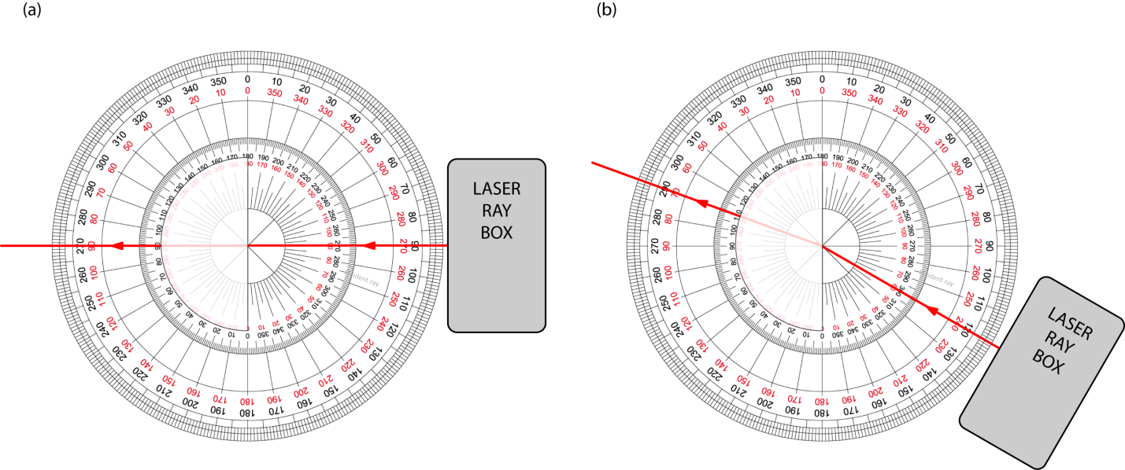

1. Complete Table 1.
2. Turn on your computer and launch the Logger Pro program. Prepare a graph of $\sin{θ_{1}}$ vs. $\sin{θ_{2}}$. This is your Graph 1. Arrange your graph to get a proper display according to the tutorial *How to prepare a graph*.
3. Find the refractive index of the acrylic using a graph of this data set and a linear fit. Select the graph, click Analyze then Linear Fit.
4. Click File then Page Setup… and select the Landscape orientation. Click OK. **Print** your Graph 1 to a pdf file. Make sure you use the printer CutePDF to print the graph.
5. We strongly recommend that you save all the work you do during the lab in case you need to review it later. Click File 🡪 Save As… to save your experiment file (suggested name: *refraction_YOUR_NAMES.cmbl*). You can either send the file to yourself by email or save it on a USB key.

### Light dispersion

Note: You need white light for this part. You will have to share this setup with other teams. Your TA will show you where to find these setups in the classroom.

1. Place the prism in the light path as shown in the figure below. When you were working with the rectangular cube, the two refractions (or bendings) upon entry and exit of the ray were from parallel surfaces and thus bent the ray in one direction and then back by an equal amount. The different surface angles of the prism bend the ray in the same direction for both entry and exit. The various colours making up the white light actually have slightly different refractive indices in the acrylic material. Thus, the action of double bending will give slightly different exit angles for the different colours, producing the rainbow effect.

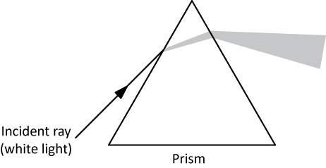

1. Describe what happens to the ray of white light. Which colour has the largest refraction angle and which has the smallest?

### Convex and concave lenses

1. Switch the laser ray box to three laser beams.
2. Place the converging lens (double convex) in the pathway of the rays. Align the lens so that the center beam is not deflected by the lens. Trace around the surface of the lens and trace the incident and transmitted rays. Indicate the incoming and the outgoing rays with arrows in the appropriate directions.
3. Measure the distance from the center of the lens to the focal point of the rays. Since the incident rays are parallel (assuming source at infinity), this separation should represent the focal length of the lens.
4. This time take the diverging lens and place it in the pathway, perpendicular to the rays as always. Note how it causes the rays to now diverge instead of converge. Trace the outline of the lens and the exiting rays.
5. With the lens removed extend your drawn rays back to where they meet. This point where they “appear” to originate from is called the location of the “virtual” image. Since the original rays are initially parallel (source at infinity), the distance from the centre of the lens to the point is also the focal length of this diverging lens. Note that this time, the focal length is a negative.
6. The converging lens and this diverging lens have the same radius of curvature. How do their focal lengths compare? What happens if the two lenses are placed together in the pathway of the rays?

### Real images and thin lens equation

From this point onwards you will be using the optical bench and the real thin lenses. You can pull the optical bench closer to you and put away the laser ray box and acrylic pieces.

1. Find the 10 cm double convex lens. You will use two methods to find the focal length of that converging lens.

**Method 1: Object at infinity**A very distant object ($p→∞$) will have a real image at the focal point of a converging lens, and the image distance $q$ then is equal to $f$ (substitute $p →∞$ in eq. 2 to prove this result). The distant object should be at least 20 meters from the lens. For our purpose, trees or clouds will be satisfactory.

1. Place the screen and the lens on the optical track. Aim the track at a window to the outdoors to receive light from distant objects. The arrangement of the track should be: Window, 10 cm lens then screen.
2. Adjust the position of the lens on the track until you see a clear image on the screen.
3. Measure the focal length and estimate its uncertainty (depth of focus).

**Method 2: Object closer than infinity**If a number of different object distances, $p$, and their corresponding image distances, $q$, are measured, you can make a graph of $1/q$ is plotted against $1/p$. Using the thin lens equation, the focal length can be determined from such a graph.

1. Attach the light source near one end of the track at the 10 cm mark, facing toward the higher distance markings. Place the 10 cm double convex lens on the track, at the 25 cm mark (you have $p$ = 15 cm). Attach the screen to the track and position it so that light from the light source passes through the lens and strikes the screen. Your setup should look like the image below.

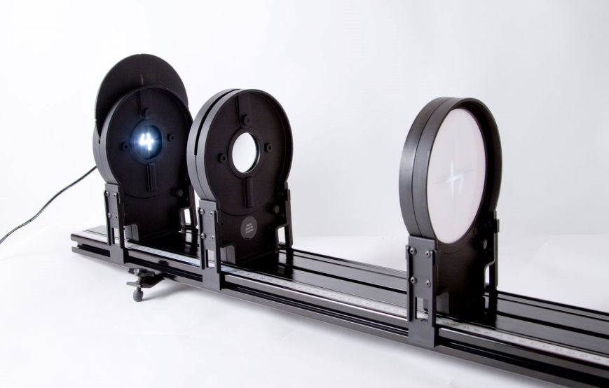

1. Turn the light source wheel until the number “4” is visible in the opening. This will be your “object” for this investigation. Adjust the position of the screen until you see a clear image on the screen. This may require some trial-and-error.
2. Record the distance between the light source and the lens as “Object distance” and the distance between the lens and the screen as “Image distance” in Table 2.
3. Repeat the last two steps with the other values of $p$ indicated in Table 2 to complete the table.
4. Prepare a graph of $1/q$ vs. $1/p$. This is your Graph 2. Make a linear regression and prepare your graph for printing. **Print** your Graph 2 to a pdf file. Make sure you use the printer CutePDF to print the graph. Save your experiment file (suggested name: *f_YOUR_NAMES.cmbl*).
5. Depending on the conditions, the image can be larger or smaller than the object. Can you create the conditions which cause the image and the object to have the same size?

### Virtual images and the microscope

1. Prepare the following setup on your optical bench: the light source at the 10 cm mark, the 10 cm double convex lens at the 30 cm mark and the 20 cm double convex lens at the 65 cm mark.
2. You have assembled a microscope. The light source is the object you want to observe. The 10 cm lens is called the objective lens and the 20 cm lens is called the eyepiece. Turn on the light source and look at the number “4” through the eyepiece. If necessary, adjust the position of the eyepiece to observe a sharp image.
3. Is the image larger or smaller than the object? Is the image real or virtual?
4. Record the distance between the object (the light source) and the objective lens. Record the distance between the two lenses.
5. Assuming that the focal lengths are exactly 10 cm and 20 cm, calculate the magnification factor of your microscope, $M=\left|\left(q_{o}/p_{o}\right)\left(q_{e}/p_{e}\right)\right|$, where $p_{o}$ and $q_{o}$ refer to the image produced by the objective while $p_{e}$ and $q_{e}$ refer to the image observed through the eyepiece. (see the figure below).

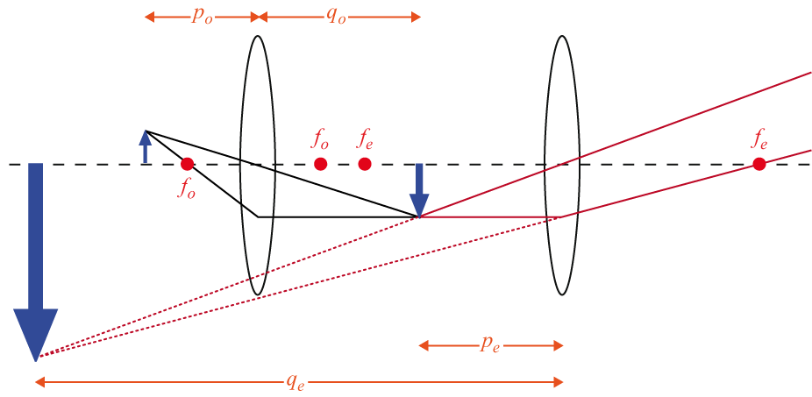

### Cleaning up your station

1. Submit your graphs in Brightspace. If you locally saved your files, send them to yourself by email. Pick up your USB key if you used one to save your files. Turn off the computer.
2. Make sure the laser ray box is turned off. Put back the four acrylic pieces and the 360° protractor together.
3. Make sure the white light source is turned off. Put the light source, the two lenses and the screen back on the optical track.
4. Recycle scrap paper and throw away any garbage. Leave your station as clean as you can.
5. Push back the monitor, keyboard and mouse. Also please push your chairs back under the table.